# Honda Internship Project

# Intern Book Project Report

**Date:** August 13, 2025  
**Prepared for:** Honda Cars India Ltd.

## 1. Problem Statement

Internship programs frequently encounter difficulties in effective coordination between mentors and interns. Challenges include unclear task assignments, limited progress visibility, and scattered reporting, leading to delays, reduced engagement, and inefficiency.

## 2. About the Project

InternshipHub is a SaaS single-page application (SPA) that streamlines mentor-intern collaboration through role-based dashboards, task management, progress tracking, and intuitive communication tools. Built with ReactJS, Tailwind CSS, React Router, and Context API, it offers a scalable foundation for internship program management.

## 3. Project Objectives

* Streamline internship workflows with centralized task and progress tracking.
* Provide mentors with complete visibility over intern performance.
* Deliver interns a user-friendly interface to manage and report on tasks.
* Ensure a responsive, maintainable, and scalable application structure.

## 4. Requirements

**Functional:**

* Role-based authentication (mentor/intern)
* Task creation, assignment, editing, deletion
* Intern task viewing, progress updates, and mentor communication
* Customized dashboards per role

**Non-Functional:**

* Responsive UI for desktop and mobile
* Smooth animations and transitions
* Modular and reusable code

## 5. Technical Architecture

**Frontend:**

* ReactJS functional components with hooks
* Tailwind CSS for styling
* AOS for animations
* React Router for routing
* Context API for authentication and global state

**Folder Structure:**

src/  
 ├── App.jsx  
 ├── main.jsx  
 ├── index.css  
 ├── assets/logo.svg  
 ├── contexts/AuthContext.jsx  
 ├── data/dummyData.js  
 ├── components/  
 │ ├── layout/ (Navbar, Footer)  
 │ ├── auth/ (Login, Signup)  
 │ ├── dashboard/ (MentorDashboard, InternDashboard)  
 │ ├── mentor/ (InternManagement, TaskManagement, Reports)  
 │ ├── intern/ (MyTasks, Progress)  
 │ ├── static/ (LandingPage, About, Review, Contact)  
 │ └── ProtectedRoute.jsx  
 └── utils/

## 6. Key Features

* Role-based dashboards
* Task assignment & progress tracking
* Landing page with animated sections
* Mentor and intern-specific views
* Contact forms for communication

## 7. Sample Code

**Role-Based Dashboard:**

function RoleBasedDashboard() {  
 const { user } = useAuth();  
 if (!user) return null;  
 return user.role === 'mentor' ? <MentorDashboard /> : <InternDashboard />;  
}

## 8. Data Model

**User:**

{  
 "id": "uuid",  
 "name": "string",  
 "role": "mentor|intern",  
 "email": "string",  
 "tasks": ["taskId"]  
}

**Task:**

{  
 "id": "uuid",  
 "title": "string",  
 "description": "string",  
 "status": "pending|in-progress|completed",  
 "priority": "low|medium|high",  
 "dueDate": "date",  
 "assignedTo": "userId"  
}

## 9. UI/UX Highlights

* Dark mode default
* Progress bars & status badges
* Hover tooltips for tasks
* Smooth modal interactions
* Fully responsive design

## 

## 10. Project Screenshots

1. **Landing page hero**

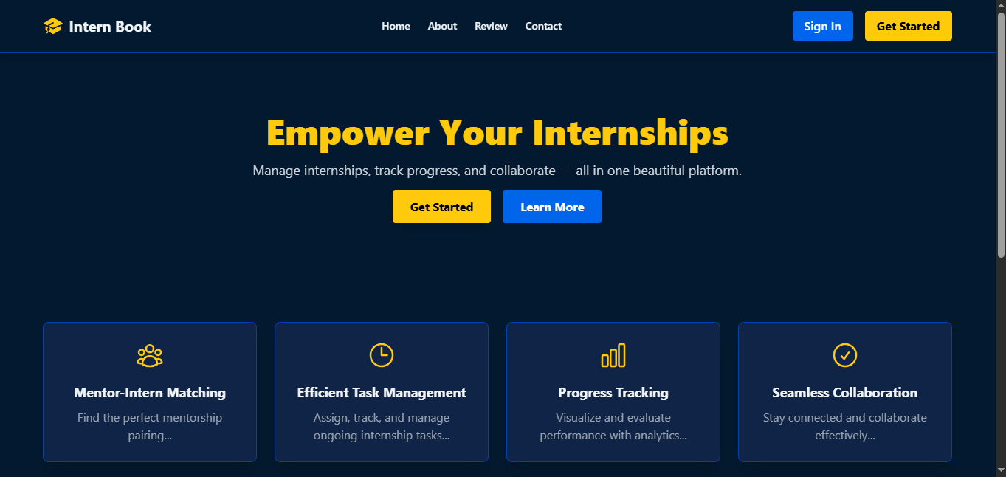

1. **Sign Up Page**

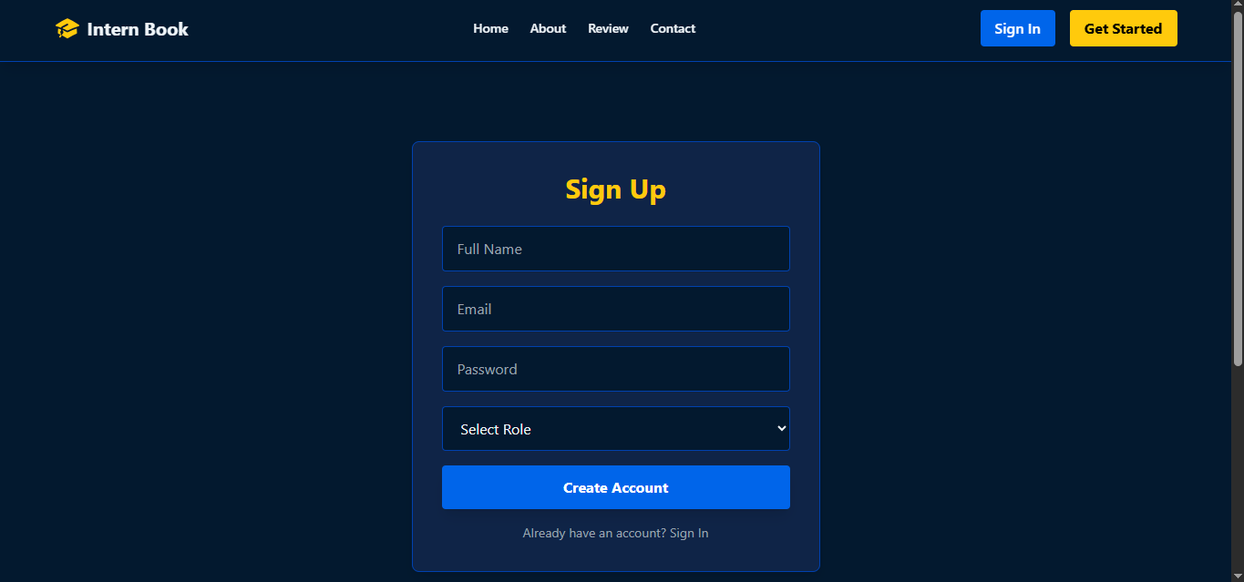

1. **Sign In Page**

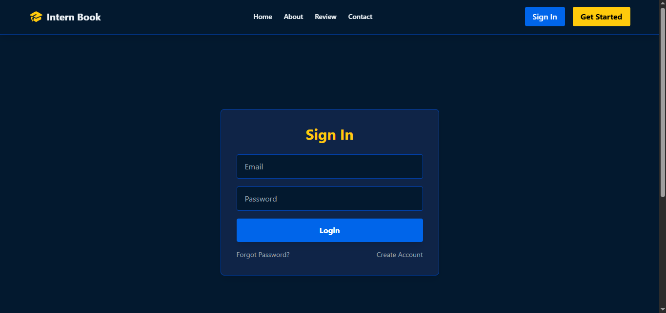

1. **Mentor dashboard with intern progress**

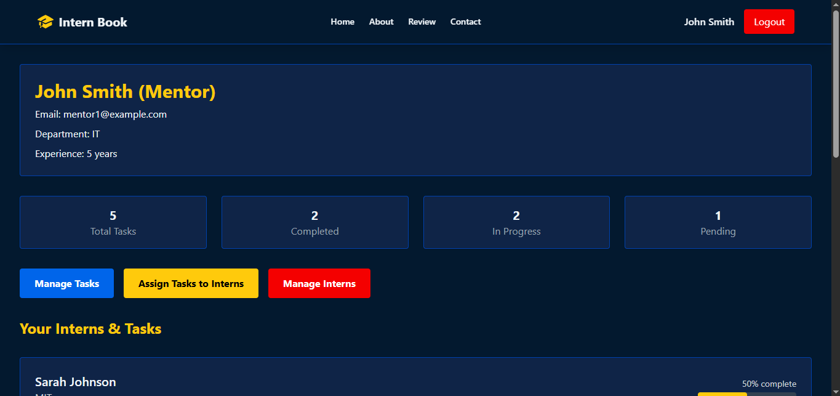

1. **Intern dashboard with tasks**

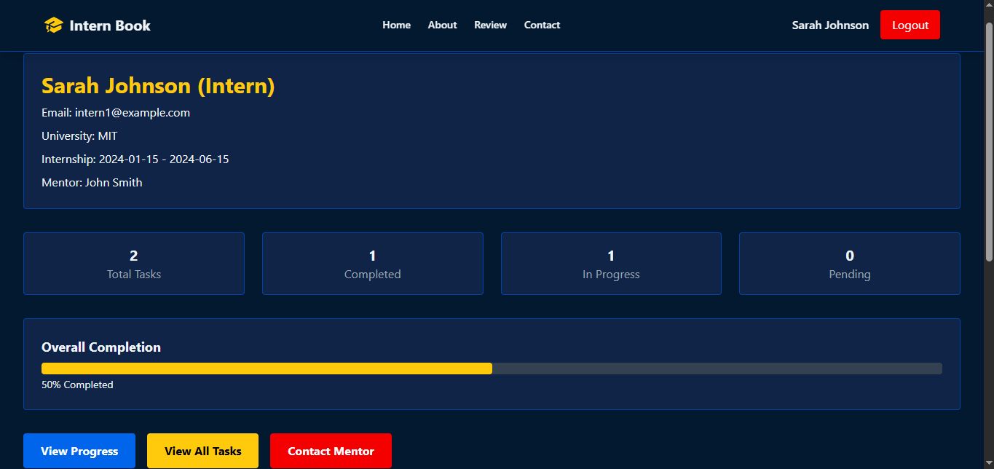

1. **Modals for task management**

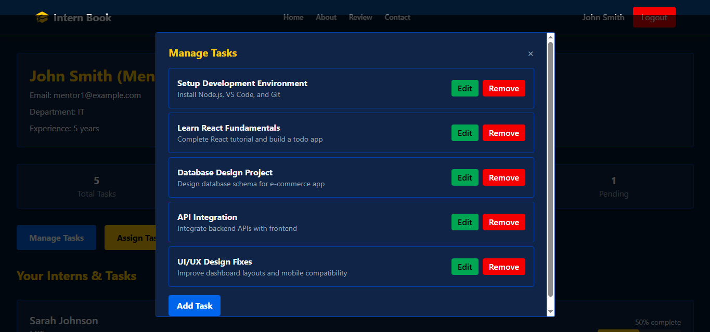

1. **Modal for Assigning Task**

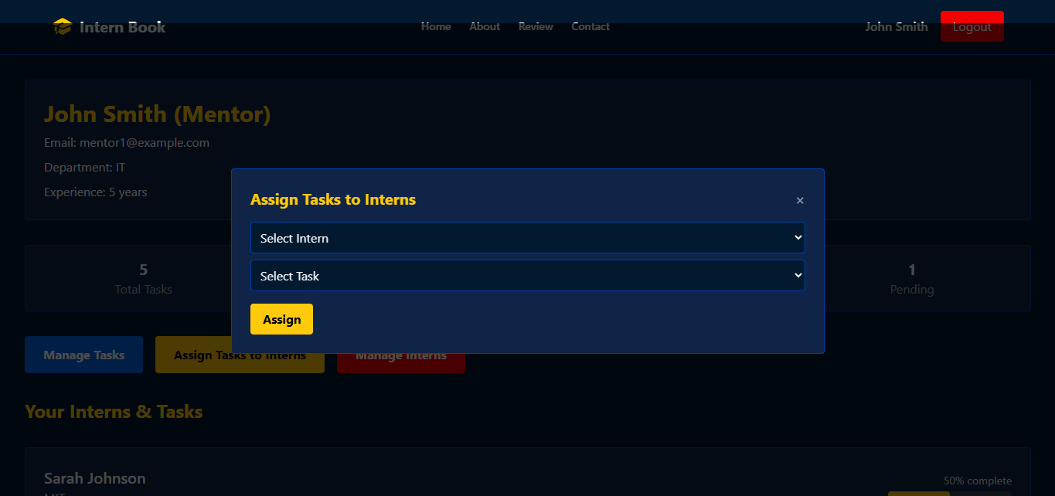

1. **Modal for Managing Interns**

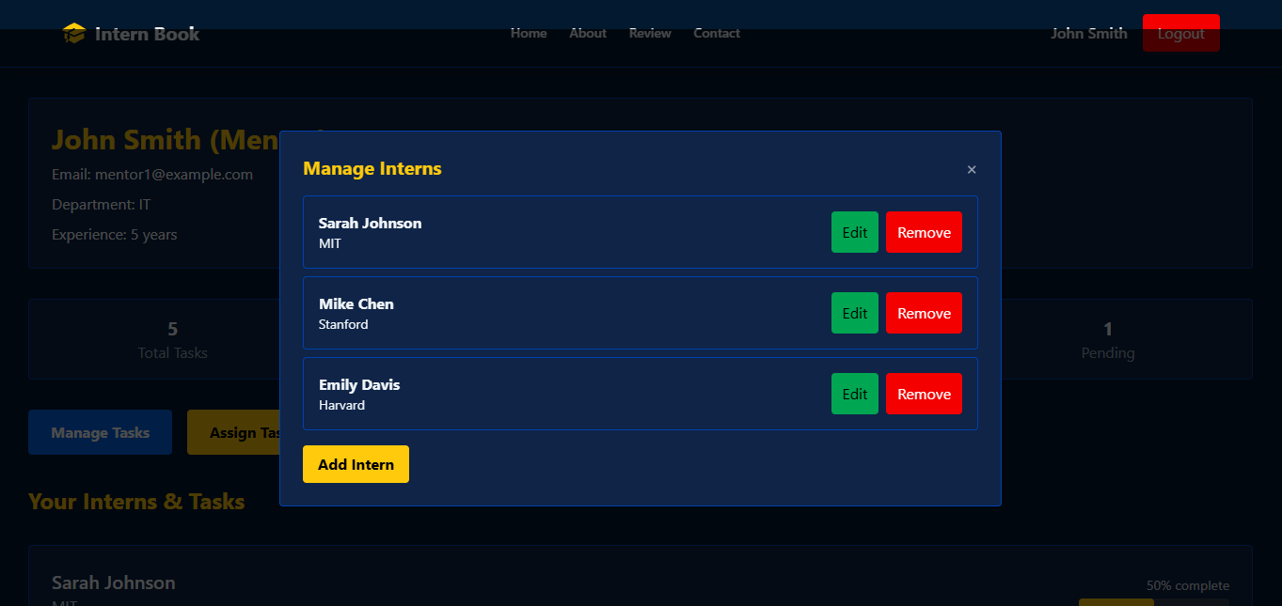

1. **About Page**

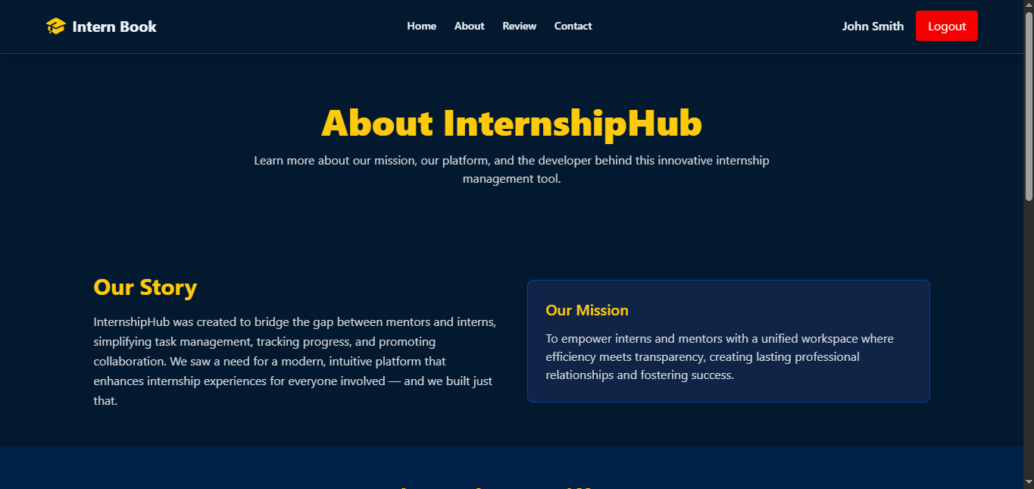

1. **Review Page**

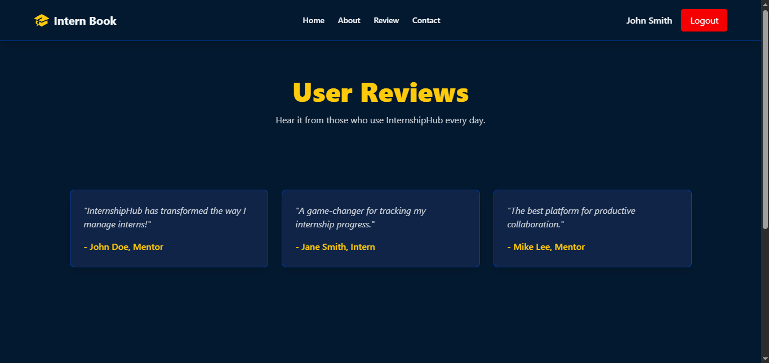

1. **Contact Us Page**

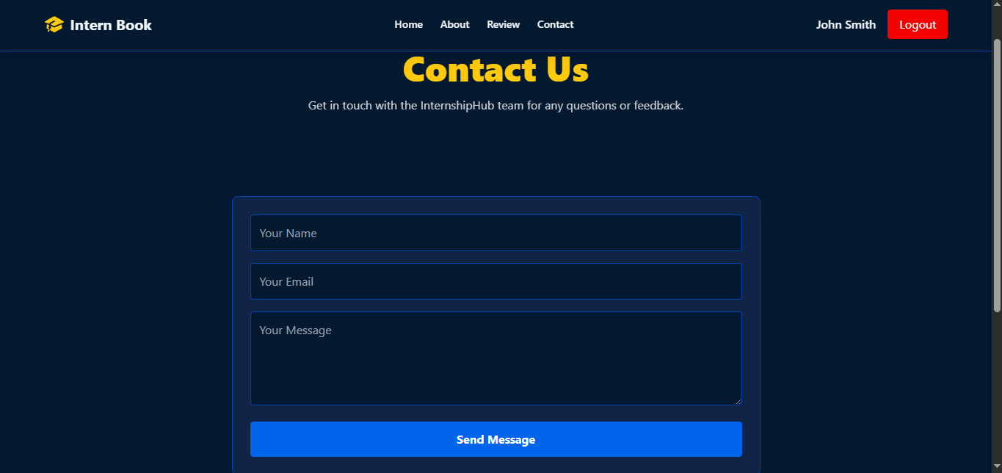

## 11. Final Verdict

InternshipHub solves critical pain points in internship management, offering an intuitive, modern interface backed by a clean, modular codebase.

## 12. Future Enhancements

* Backend API integration for persistence
* Real-time updates via WebSockets
* Admin role with analytics
* Mobile application version
* In-app notifications and messaging

## 13. Real-Life Usage

* **Corporate Internship Programs:** Streamlined task assignments and progress tracking.
* **Academic Institutions:** Faculty oversight with structured feedback.
* **Startup Environments:** Lightweight management without complex setups.
* **Remote Internship Coordination:** Location-independent collaboration.
* **HR & Training:** Data-driven reports for program evaluation.

## 14. Future Scope

* Backend API with database integration
* Real-time collaboration via WebSockets
* Advanced analytics and reporting
* Multi-role permissions
* Mobile app development
* Third-party integrations (Slack, Teams)
* Automated alerts and gamification
* Localization and accessibility compliance
* Document management capabilities

## 15. Developer Information

**Developer:** Kartik Kumar  
**Contact:** +91 9368847936   
**GitHub:** <https://github.com/kumarkartik001>  
**LinkedIn:** <https://linkedin.com/in/kartik-kumar-kk>